Campus Talk –
Quality Control Management Plan Document

Team – 5
IT-632 Software Engineering
Instruction: Prof.Asim Benerjee

Revision History

Version | Date | Author | Description
1.0 |  | Darshil | Created

Contents

- Introduction
1.1 Purpose of the Project Quality Plan
1.2 Scope
1.3 References
1.4 Acronyms

- Methodology

- Quality Management Plan
3.1 Quality Planning
    - Defining Quality Standard
    - Measuring Project Quality

3.2 Quality Assurance Plan and Control

- Requirement Document

- Test

- Introduction

1.1 Purpose of Project Quality Management Plan

Quality Mangement Plan is to ensure that you're providing the products having the good qulaity. Quality Planning, Quality Assurance and Qaulity control are the main components of Quality management plan. This document consist of different methodologies used for ensuring the specific requirement are fullfilled in timely and cost effectively manner. The purpose of this document is not only to focus on product/service quality, but also the means to achieve it. Use metrics to develop strategies for improving software process and consequnce quality of the product.

1.2 Scope

Its aim is to assure that results and deliverables of the projects of high quality and meet the specifications set in the SRS. It define the approaches for Software quality personl to monitor and assesses software development process and products. The scope of this plan includes the qualities practices and procesdures, processes and deliverable produced during the course of CampusTalk Project.

1.3 Refernces

1. SRS
2. Desing Document
3. Project Plan

1.4 Acronyms

SRS : System Requirement Specification
PDCA – Plan Do-Check-Act
SDLC : Software Development Life Cycle

- Methodologies
To ensure quality of product we're using methodlogy inspired by Deaming's Plan Do-Check-Act Cycle
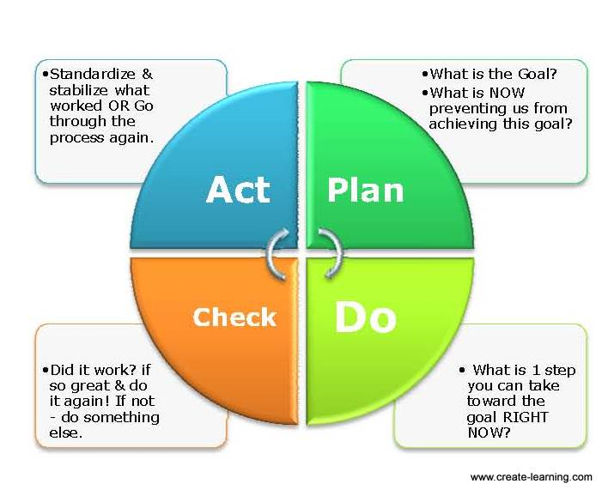

PLAN
Revisit the goal.
Explore (quickly) one and only one, obstacle in our way of achieving the goal

DO
In reference to the one obstacle choose one and only one action step that can move us closer to the goal.

CHECK
Now that you have have done that one thing what worked?

ACT
If it worked; Can you do more and continue through the process again?
If it did not work; Have you stopped doing it and go through the process again.

Certain activities are performed to ensure the quality of the product:

Maintainance of documentation standard: All document must be in proper format and complete on time as per project timeline.

Insepection of revies of all document: Every document must be reviewed by all the team memebers and changes are suggested and updated.

Varification and Validation: Varification activity is done at the end of every phase and present phase is complimented by the assumption made in previous phase. Validated by the various team members.

Coding guideline followed in the whole project coding phase: Following the coding Standard helps u to read, understand and maintain code easily.

Easy to maintain: Handle the changin need of customer, the hardware etc.

- Quality Management Plan

The final aim of any project is to come up with the solution that is acceptable by the customer. Quality assurance plan teaches desired quality parameters. For this we need to make sure that every intermediate product

3.1 Quality Planning

Define Quality Standard
There are some features need to be handle to get the quality product.
- The s/w system should do everything that is documented in SRS document (Requirements)
- Best mechanisms for handling erors. It's better to use Error Prevention then Erro4 Detection.
- Quality Assurance is followed through the whole project life Cycle.
- Extra features always weight's one software. It act as bonus for client who is always looking for such offer.
- The recovery rate must be higher.

Measuring Quality Project
Factors which contributes in meansuring Project Quality are:

Review Process:
All the documents are created, updated and reviewd as per need. All the team member or part of the team check whether the document satisfied the norms that have been set down. If any conflict occurs during document review try to mark that points and further try to resolve it.

An Anamoly IEEE standard is,
Any condition that deviates from expectation based on requirement specification, design documents, user documents, and so on from someone's perceptions or experiences. Anomolies may be found during, but not limited to, the review, test, analysis, compilation, or use of software products or applicable documentaiton.

All the document and product being created in the spam of SDLC is well reviewd by each members of the team. As our PDCA when the document is completed, proper reviewing has to be done and based on that proper action should be taken. Just like that ever single module is being reviewd and tested.

Cost: The software is developed in planned time withhout any work overhead. As main concern is learning curve of the project.

3. 2 Quality Assurnce plan and Quality Control

Qulaity control: Related to the product qality
Quality Assurance: Related to the process Quality

Focusing on Quality Assurances lead to “High Quality” software. Hence the more foucs is given to the Quality assurance.Quality Assurance plan is to specify the activities that need to be performed for identifying and removing defects, and tools and methods used for that purpose.

Quality Assurance plan should specify all stpes needed to come up with a quality product. he purpose of quality assurance plan is to direct and facilitate the establishment of quality assurance activities with in processes used to deliver right products and services to the clients.

Quality Assurance Procedures:

1. Structured walkthrough are applied for detecting errors and improving products at any 2. process stages.
2. Individual evaluation of process activities or finished products is done through checklist and meetings.
3. Indipendend examination of the product is carried out.

Responsible: Quality Assurance Team

4. Required Document

Following documents are needed to ensure that quality of the product is maintained.

Software Requirement Specificaiton:
Requirement Analysis : Define User Requirement
Requirement Specification: Document that Requirements.

SRS Can be used as a reference for checking final product.Agreement betwene Client and Developer. Define “What the System is to do?” . SRS is imcorporated and met with desired quality in the product.

Project Plan
Project planning includes development of overall project sturcture, activitites and the work plan/timeline that will form the basis of the project management process throughout the project lifecycle. Project shceduling has to be followed to obtain quality product.

Software Design Specification:
It's Document between requirement specification to the final solution. Various diagrams are created like ER Diagram, Seuqntial Diagram, etc. Module detail(Algorithm and Datasturcture) is given so that we can directly implement them in different programming language.

5. Test

Testing is the process of analyazing a software item to detect the difference between existing and required condition and evalatue the features of the sofware item. Various testing must be done on project to ensure that all the requirement in SRS fullfilled efficiently. The test log and test report of CampusTalk ensure that all modules work correctly.

